## A Project Report on

**“Sunflower Solar Tracking System”**

*Submitted By:*

**Mr. Neel Ashok Shingavi**

**Mr. Prasad Deepak Wadkar**

**Ms. Tanmayi Rakesh Vahutre**

**Ms. Madhura Bhagwant Sawant**

TYCM (2024-25)

Under the guidance of

**“Ms. Suparna S. Naik”**

In Partial Fulfilment for the Award of Diploma in Computer Technology



**Department of Computer Technology**

BHARATI VIDYAPEETH’S JAWAHARLAL NEHRU INSTITUTE OF TECHNOLOGY (POLYTECHNIC)

**Katraj, Pune – 411043.**

**2024-2025**



**BHARATI VIDYAPEETH’S JAWAHARLAL NEHRU INSTITUTE OF TECHNOLOGY**

**(POLYTECHNIC)**

**KATRAJ, PUNE – 411043**

**2024 -2025**

DEPARTMENT OF COMPUTER TECHNOLOGY

**CERTIFICATE**

This is to certify that **Mr. PRASAD DEEPAK WADKAR** from BHARATI VIDYAPEETH’S Jawaharlal Nehru Institute of Technology (Poly), Pune, having Enrollment No: 2201250158 has completed Project Planning Report having title **“Sunflower Solar Tracking System”** in a group consisting of 4 Candidates under the guidance of the faculty **Ms. Suparna S. Naik.**

**Name of students:**

**Mr. Neel Ashok Shingavi**

**Mr. Prasad Deepak Wadkar**

**Ms. Tanmayi Rakesh Vahutre**

**Ms. Madhura Bhagwant Sawant**

**Date:**

**Place:** Pune, Maharashtra

|  |  |  |
| --- | --- | --- |
| **Ms. Suparna S. Naik** | **Mr. A.P. Shinde** | **Mr. R.R. Utturkar** |
| **Project Guide** | **Head Of Department** | **Principal** |

**ACKNOWLEDGEMENT**

We would like to extend our heartfelt appreciation to everyone who contributed to the successful completion of this project. Our sincere thanks to my project team members for their dedication and collaboration throughout the project. Each member played a significant role in shaping the project outcome.

Special thanks to our professor “**Ms. Suparna S. Naik**”, for their valuable guidance and feedback, which enriched our work.

Next, we would like to express our gratitude towards all the teachers of the Computer Department and also, the non-teaching staff for letting us use the computer laboratory resources which helped us in working on the project even in the college.

We are indebted to the head of the Computer Department **“Mr. A.P. Shinde”** who provided his insightful knowledge that aided us in progressing through our project.

We are also thankful to our respected principal sir **“Mr. R.R. Utturkar”** who was an inspiration and also, was a great help whenever we needed him.

Last but not the least we would like to thank all the **Authors, Writers, Owners, Developers, Sponsors** of all the resources (are mentioned at the end) which were used by us during the project.

I’d like to express my heartfelt gratitude to the college of Bharati Vidyapeeth’s Jawaharlal Nehru Institute of Technology for providing us the opportunity to collaborate on the project **“Sunflower Solar Tracking System”**.

**Name of students:**

**Mr. Neel Ashok Shingavi**

**Mr. Prasad Deepak Wadkar**

**Ms. Tanmayi Rakesh Vahutre**

**Ms. Madhura Bhagwant Sawant**

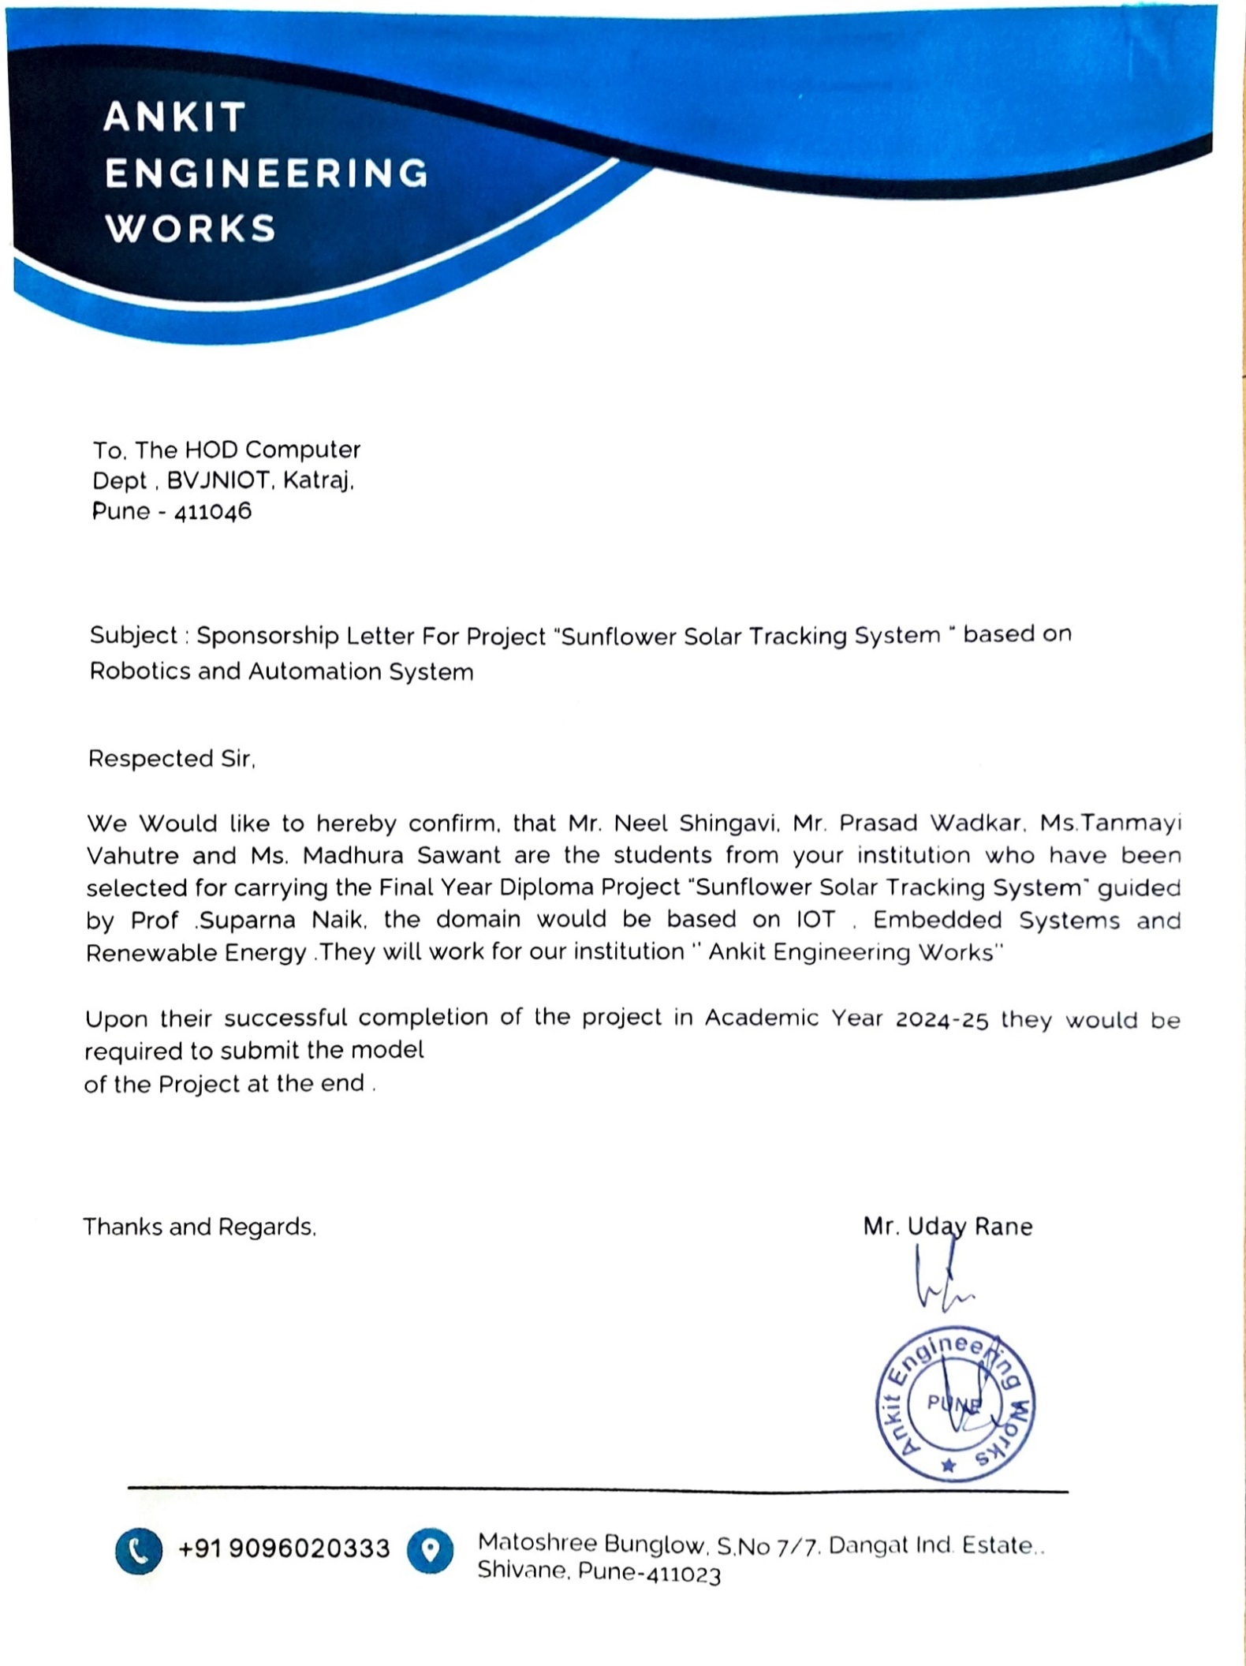

#### CERTIFICATE BY GUIDE

This is to certify that the following students **“Mr. Prasad Deepak Wadkar”** from Computer Technology have successfully completed the project work on **“Sunflower Solar Tracking System”** for the academic year 2024-25 under my direct guidance.

**Date: “Ms. S. S. Naik”**

**Place:** BVJNIOT, Pune -43 Project Guide

#### CERTIFICATE BY HEAD OF THE DEPARTMENT

This is to certify that the following students **“Mr. Prasad Deepak Wadkar”** from Computer Technology have successfully completed the project work on **“Sunflower Solar Tracking System”** for the academic year 2024-25 under the guidance of “Ms. S. S. Naik”.

**Date: “Mr. A. P. Shinde” Place:** BVJNIOT, Pune -43 Head of Department

**TABLE OF CONTENT**

|  |  |
| --- | --- |
| Title Page | I |
| Certificate | II |
| Acknowledgement | III |
| Sponsorship Letter | IV |
| Certification by Guide | V |
| Certification by Head of Department | VI |
| Tables of Content | VII |
| Index | VIII – IX |
| Abstract | X |

**INDEX**

|  |  |  |
| --- | --- | --- |
| **SR. NO** | **TITLE** | **PAGE NO.** |
| **1.** | **INTRODUCTION**   * 1. Introduction to the project   2. Problem statement   3. Objective   4. Scope of the Project   5. Motivation | **1** |
| **2.** | **BACKGROUND**   * 1. Basics of Solar Tracking   2. Types of Tracking Systems   3. Comparison: Fixed vs Tracking Panels | **6** |
| **3.** | **RELATED WORK**   * 1. Literature Survey   2. Review of Literature Survey | **10** |
| **4.** | **RESEARCH APPROACH**   * 1. System Design Overview   2. System Requirements      1. Software Requirement      2. Hardware Requirements | **13** |
| **5.** | **SYSTEM MODEL**   * 1. Block Diagram   2. Circuit Diagram   3. Arduino Code Explanation   4. Flow Chart   5. Conceptual diagram   6. Data Flow Diagrams (DFD)   7. State Chart | **17** |

|  |  |  |
| --- | --- | --- |
| **6.** | **APPLICATIONS** | **34** |
| **7.** | **RESULTS** | **37** |
| **8.** | **TESTING**   * 1. System Testing   2. Testing Techniques   3. Accuracy Evaluation | **41** |
| **9.** | **FUTURE SCOPE** | **45** |
| **10.** | **CONCLUSION** | **50** |
| **11.** | **RESEARCH PAPER** | **52** |
| **12.** | **CERTIFICATES** | **59** |

ABSTRACT

The universe comprises numerous galaxies and planets, with Earth being the most habitable. Earth provides various resources that enhance human quality of life. One such resource is renewable energy. This project focuses on harnessing a specific type of renewable energy and converting it into usable power. Among the various sources, solar energy is utilized, being one of the most abundant and efficient. The sun, the selected energy source, is inexhaustible and replenishes daily. Solar energy increases throughout the day, illuminating the planet. This energy can be transformed into different forms, particularly electricity, which is the primary objective of this project. The solar tracker identifies the sun at daybreak and follows its path throughout the day, automatically resetting for the next cycle. The captured solar energy is stored and utilized efficiently. This system benefits businesses with multiple locations by replacing traditional power sources and reducing electricity costs. Additionally, solar tracking improves energy capture efficiency by ensuring optimal alignment with the sun. This enhances sustainability efforts by reducing reliance on non-renewable sources, minimizing environmental impact, and promoting greener alternatives. Widespread adoption of this technology can conserve power, reduce expenses, and offer low maintenance while generating profit. With the growing global demand for energy, implementing solar tracking systems on a larger scale can contribute to a cleaner, more energy-efficient future.

**Index Terms** - Dynamic Solar Panel, Sunflower method, Public awareness, Smart renewable sources, Smartflower , Green Technology.

# CHAPTER 1

# INTRODUCTION

#### CHAPTER 1

**INTRODUCTION**

* 1. **INTRODUCTION TO PROJECT:**

In recent times, sustainable energy solutions from renewable sources have become increasingly popular. Solar power, in particular, has emerged as one of the most plentiful options. In the last few years, solar technologies have been adopted across various sectors, including homes, industries, and educational facilities. Solar systems have shown favorable efficiency and maximum output. While fixed solar panels are currently widespread, they are less efficient than their movable counterparts. A solar tracker is a mechanism that uses light-based or solar sensors to orient a solar photovoltaic panel or lens towards the sun. The main benefit of solar energy is its unlimited and clean nature. To optimize solar energy collection, it's crucial to position the panel perpendicular to the sun's rays. The sunflower method, also known as solar tracking, is considered ideal, as aligning solar panels perpendicular to solar irradiation by following the sun's movement results in higher efficiency. It is a photovoltaic (PV) system designed to enhance the visibility of solar technology while also improving the landscape and architecture through aesthetic considerations. Smart flowers are modeled after sunflowers and incorporate all necessary components for electricity generation and storage, such as solar panels, inverters, wiring, and batteries. Beyond generating solar power, another goal of installing smart flowers is to increase public awareness and encourage the adoption of renewable energy. Unlike traditional rooftop solar panels, which typically serve as primary energy sources for properties, photovoltaic systems like smart flowers are not usually used in this capacity. Instead, solar flowers function as supplementary systems to rooftop solar installations or other green building techniques, symbolizing the environmental advantages of renewable energy.

* 1. **PROBLEM STATEMENT**

This research focuses on addressing the challenge of maximizing solar energy capture in photovoltaic systems to boost their efficiency and effectiveness. Traditional stationary solar panel setups are constrained by their inability to adjust to shifting sunlight angles throughout the day, resulting in subpar energy generation. This inefficiency is particularly evident in areas with fluctuating weather conditions or seasonal variations in sunlight intensity. Consequently, the research aims to develop a solution that actively adjusts solar panel orientation to follow the sun's trajectory, thereby enhancing energy yield and improving the overall performance of solar energy systems. The primary goal is to create and implement a sun-tracking mechanism, such as the Sunflower Solar Tracker System, capable of surmounting these limitations and achieving greater energy output, efficiency, and dependability.

Incorporating sensors, microcontrollers, and a dual-axis tracking system, the model ensures precise solar tracking with minimal manual intervention. Additionally, this project emphasizes low-cost design and energy-efficient components to make the system scalable and accessible for broader use. The proposed solution is also aligned with environmental sustainability goals, reducing dependency on fossil fuels and supporting the global transition toward greener energy alternatives. Through this problem formulation, the study seeks to tackle the urgent need for innovative methods to optimize solar energy capture and promote the widespread adoption of renewable energy technologies.

* 1. **OBJECTIVE**

The primary objective of this research is to design and implement a **Sunflower Solar Tracking System** that efficiently harnesses solar energy by dynamically adjusting the position of solar panels to track the sun’s movement throughout the day. This system aims to maximize energy absorption, improve efficiency compared to stationary panels, and ensure optimal power generation. Additionally, this research explores the benefits of solar tracking technology in reducing reliance on non-renewable energy sources, lowering electricity costs, and promoting sustainable energy solutions for residential, commercial, and industrial applications. The study also focuses on enhancing automation in solar energy collection, minimizing energy wastage, and evaluating the economic feasibility of large-scale solar tracking deployment. By integrating smart control mechanisms, the system seeks to optimize solar energy utilization and contribute to a greener, more energy-efficient future.

* 1. **SCOPE OF THE PROJECT**

The Sunflower Solar Tracking System project involves designing and developing a solar tracking mechanism that enhances energy capture by automatically aligning solar panels with the sun’s movement. It uses a dual-axis tracking system to follow the sun from sunrise to sunset, improving energy conversion compared to fixed panels. At the end of the day, the system resets itself for the next cycle without manual input. By maintaining the optimal angle with the sun, it ensures maximum sunlight exposure and efficient energy generation. This system reduces reliance on non-renewable energy sources by offering a clean, renewable alternative that lowers electricity costs.

It uses microcontroller-based automation, such as Arduino, to control panel movement accurately. Captured solar energy is stored for use during low-light periods, increasing reliability. The project is scalable for residential or commercial use and supports sustainable practices by promoting clean energy and reducing environmental impact, making it a practical solution for growing energy demands.

* 1. **MOTIVATION**

With the increasing global demand for energy and the depletion of non-renewable resources, there is a growing need to shift towards sustainable and efficient alternatives. Solar energy, being abundant and renewable, offers a promising solution. However, conventional fixed solar panels cannot capture maximum sunlight throughout the day, leading to energy inefficiencies. The **Sunflower Solar Tracking System**, inspired by the natural movement of sunflowers, follows the sun to optimize light absorption. By applying this concept, the system enhances energy harvesting, reduces reliance on fossil fuels, and promotes cleaner energy. This project addresses the need for cost-effective, energy-efficient, and low-maintenance solar solutions suitable for residential, commercial, and industrial use. It aims to improve renewable energy system efficiency, support environmental conservation, and lower greenhouse gas emissions. By developing an automated, intelligent solar tracking mechanism, this research supports making solar power more accessible, economically viable, and a key component in the transition to sustainable energy.

# CHAPTER 2 BACKGROUND

#### CHAPTER 2

**BACKGROUND**

* 1. **BASICS OF SOLAR TRACKING**

Solar tracking is a technique used to enhance the efficiency of solar panels by continuously orienting them toward the sun as it moves across the sky. The primary goal of solar tracking is to maximize the amount of solar energy captured throughout the day, thereby increasing the overall energy output of the system.

There are mainly two types of solar tracking systems: **single-axis** and **dual-axis**. A **single-axis tracker** moves the panel along one direction—typically from east to west—following the sun’s path during the day. A **dual-axis tracker**, on the other hand, adjusts both the vertical and horizontal angles, enabling the panel to face the sun more directly throughout the year, including seasonal shifts in the sun’s altitude.

The basic working principle of a solar tracker involves using sensors or programmed microcontrollers to detect the sun’s position. Light-dependent resistors (LDRs) are commonly used sensors in simple tracking systems. These sensors detect the intensity of light, and the system uses this data to rotate the panel accordingly using motors or actuators. Solar tracking systems can be categorized into **active trackers** and **passive trackers**. Active trackers use electrical components like sensors, motors, and controllers to follow the sun, while passive trackers rely on natural elements such as gas pressure or thermal expansion to move the panels.

By maintaining an optimal angle between the panel and sunlight, solar trackers can significantly increase energy generation compared to fixed systems. Although they involve a slightly higher initial cost and complexity, the long-term gain in efficiency and power output often justifies the investment. Solar tracking is especially beneficial in regions with high solar availability and is increasingly being adopted in large-scale solar farms and advanced green energy applications.

* 1. **TYPES OF TRACKING SYSTEMS**

Solar tracking systems are mainly classified into **single-axis** and **dual-axis** types based on their movement. A **single-axis tracker** moves the solar panel from east to west, following the sun's daily path. It is simpler, cost-effective, and increases energy output by 25–35% compared to fixed panels. A **dual-axis tracker** moves in both horizontal and vertical directions, enabling it to follow the sun throughout the day and across seasons. This ensures better alignment and boosts efficiency by 40–45%, though it is more complex and costly.

Based on control methods, trackers are divided into **active**, **passive**, and **manual** systems. **Active trackers** use sensors and microcontrollers to adjust the panel automatically. **Passive trackers** rely on thermal expansion to move panels without electrical components, making them suitable for off-grid areas. **Manual trackers** require human intervention and are the least efficient but budget-friendly. The choice depends on project needs, cost, and desired energy output.

* 1. **COMPARISON: FIXED VS TRACKING PANELS**

| **Feature** | **Fixed Solar Panels** | **Tracking Solar Panels (e.g. Sunflower System)** |
| --- | --- | --- |
| **Orientation** | Static, set at a fixed tilt angle | Adjusts throughout the day to follow the sun |
| **Energy Efficiency** | Lower efficiency due to limited sun exposure | Higher efficiency (up to 25-40% more energy) |
| **Initial Cost** | Lower installation cost | Higher due to motors, sensors, and moving parts |
| **Maintenance** | Minimal maintenance required | More frequent due to mechanical and electrical components |
| **Complexity** | Simple design and setup | Complex system with tracking algorithm and components |
| **Space Requirement** | Less spacing needed between panels | More spacing needed to avoid shadowing due to movement |
| **Weather Sensitivity** | Less sensitive to wind or mechanical damage | More vulnerable to wind and mechanical wear |
| **Suitability** | Best for small-scale or budget-focused installations | Ideal for large-scale, high-efficiency, or research-based setups |
| **Output Consistency** | Varies with sun position; peaks only at noon | More consistent output throughout the day |
| **Examples of Use** | Rooftops, small homes, fixed farms | Solar farms, advanced research projects (e.g., sunflower system) |

# CHAPTER 3 RELATED WORK

#### CHAPTER 3

**RELATED WORK**

**3.1 LITERATURE SURVEY:**

Numerous studies and research papers have explored the concept of solar tracking systems to improve the efficiency of solar energy collection. Fixed solar panels are widely used but are limited in their ability to capture maximum sunlight throughout the day. According to research, solar tracking systems—especially dual-axis trackers—can increase energy generation by up to 40% compared to fixed systems. Studies conducted by energy researchers and institutions have shown that using sensors like Light Dependent Resistors (LDRs) combined with microcontrollers such as Arduino or PIC enhances the responsiveness and accuracy of solar trackers.

Inspiration for the **Sunflower Solar Tracking System** comes from **heliotropism**—the natural behavior of sunflowers that turn toward the sun. Various academic projects and engineering journals have successfully implemented similar bio-inspired mechanisms to mimic this behavior. Moreover, literature reveals that integrating solar tracking in developing regions can provide a cost-effective and sustainable energy solution, reducing dependence on fossil fuels.

Additionally, papers focusing on renewable energy trends highlight the importance of automation, low maintenance, and energy storage in solar projects. Studies also emphasize that solar tracking is especially beneficial in regions with high solar irradiance. The review of these works provided valuable insights into improving tracking accuracy, optimizing energy output, and minimizing costs, which guided the development of this project.

**3.2 REVIEW OF LITERATURE SURVEY**

The literature survey provides a comprehensive understanding of the advancements and applications of solar tracking systems in the renewable energy sector. Studies consistently show that solar tracking systems significantly outperform fixed solar panels by increasing energy output through better sun alignment. Research on single-axis and dual-axis trackers confirms their efficiency, with dual-axis systems achieving the highest energy gain due to their ability to follow the sun’s movement both horizontally and vertically. Previous academic projects also demonstrate the effectiveness of Light Dependent Resistors (LDRs) for sun detection and microcontrollers like Arduino for automation.

The concept of mimicking sunflower behavior, known as heliotropism, has been widely acknowledged in research as a smart and natural approach to solar tracking. Literature also supports the practicality of low-cost and energy-efficient models, which makes this technology suitable for widespread implementation, especially in developing regions. Furthermore, past studies emphasize the importance of designing systems with minimal maintenance and adaptability to different environmental conditions. Overall, the literature supports the feasibility, efficiency, and environmental benefits of developing an automated solar tracking system like the Sunflower Solar Tracker and helps in refining its design and implementation.

# CHAPTER 4 RESEARCH APPROACH

#### CHAPTER 4

**RESEARCH APPROACH**

* 1. SYSTEM DESIGN OVERVIEW

The Sunflower Solar Tracking System is designed to automatically follow the sun’s movement across the sky to maximize solar energy capture throughout the day. The system primarily consists of a solar panel, dual-axis tracking frame, Light Dependent Resistors (LDRs) as light sensors, servo motors for panel movement, and a microcontroller (typically Arduino) that processes input from the sensors and controls the motor operations. The LDRs are positioned to detect the intensity of sunlight in different directions. Based on the comparison of light levels, the microcontroller determines the sun’s position and adjusts the orientation of the solar panel accordingly. The dual-axis mechanism allows movement in both horizontal and vertical directions, ensuring optimal alignment with the sun from sunrise to sunset and across seasons. A power supply unit supports the operation of the control system, and the captured solar energy can either be stored in batteries or directly used for load applications. The system resets automatically to its initial position after sunset, ready for the next cycle.

To ensure system stability, the mechanical frame is designed to support smooth motor movement without damaging the panel or affecting the sensors. Proper calibration between sensor sensitivity and motor speed is essential for accurate tracking. Moreover, the system's modularity allows easy maintenance and upgradation, enabling future integration of IoT for remote monitoring or MPPT (Maximum Power Point Tracking) algorithms for enhanced power optimization. This intelligent and automated design not only increases energy efficiency but also minimizes manual intervention and maintenance requirements, making it a sustainable and scalable solution for modern solar energy applications.

* 1. SYSTEM REQUIREMENTS
     1. **HARDWARE REQUIREMENTS:**
        1. **Solar Panel**

Converts sunlight into electrical energy.

* + - 1. **Arduino Nano**

Acts as the microcontroller to process sensor input and control motors.

* + - 1. **LDR (Light Dependent Resistors) – 5 units**

Detects sunlight intensity to determine the sun's position.

* + - 1. **Servo Motors – 2 units**

Used for horizontal and vertical movement of the solar panel (dual-axis tracking).

* + - 1. **Motor Driver Module (Optional for high-power motors)**

Controls the motors if higher torque is needed.

* + - 1. **Resistors**

Used with LDRs to form voltage divider circuits.

* + - 1. **Battery (Rechargeable)**

Stores the generated solar energy for later use.

* + - 1. **PCB**

For connecting the components.

* + - 1. **Power Supply (for Arduino/motor during testing)**

External 5V/9V supply during programming and debugging.

* + 1. SOFTWARE REQUIREMENTS:
       1. **Arduino IDE**

Used to write, compile, and upload code to the Arduino microcontroller.

Supports libraries for controlling servo motors and reading LDR values.

* + - 1. **Arduino Libraries**

Servo.h: Required for controlling servo motor movements.

* + - 1. **Embedded C / Arduino C Language**

Programming language used in the Arduino IDE to write logic for sun tracking, sensor reading, and motor control.

# CHAPTER 5 SYSTEM MODEL

#### CHAPTER 5

**SYSTEM MODEL**

* 1. BLOCK DIAGRAM
     1. DIAGRAM:

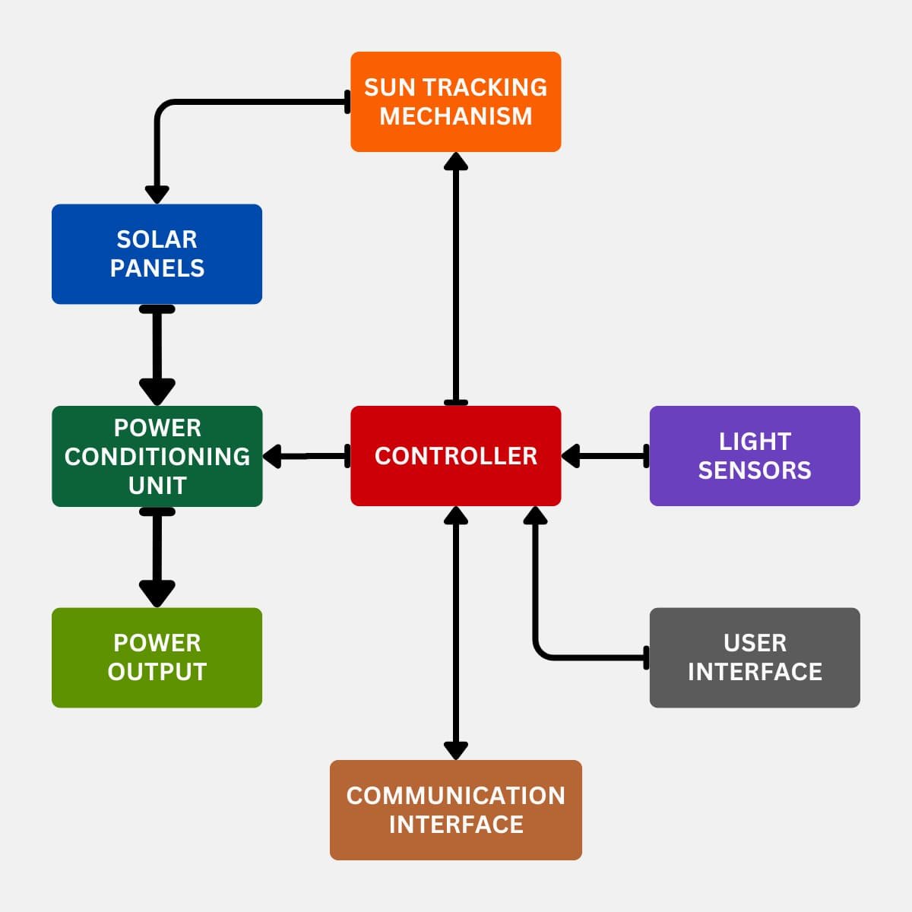

* + 1. **EXPLANATION:**

**1. Solar Panels**

The solar panels are the core component responsible for converting sunlight into electrical energy. They are mounted on a tracking structure that allows them to move in alignment with the sun. By maintaining an optimal angle, they maximize the absorption of solar radiation throughout the day, thereby increasing energy output.

**2. Sun Tracking Mechanism**

This mechanism physically adjusts the position of the solar panels to follow the sun's path from sunrise to sunset. It is typically driven by motors and is directed by signals from the controller. The purpose is to keep the panels perpendicular to the sun’s rays for as long as possible, improving the efficiency of power generation.

**3. Light Sensors**

Light sensors detect the intensity and direction of sunlight. These sensors provide real-time data to the controller, which determines whether the sun has shifted enough to require repositioning of the panels. This is a crucial input that ensures accurate and timely tracking of the sun.

**4. Controller**

The controller acts as the brain of the system. It processes inputs from the light sensors and user interface, and accordingly sends commands to the sun tracking mechanism. It also manages the data flow to and from the communication interface and ensures coordination among all subsystems, including energy regulation and movement control.

**5. Power Conditioning Unit**

This unit receives raw electrical power from the solar panels and converts it into a stable and usable form. It typically includes inverters (for converting DC to AC), voltage regulators, and filters. This ensures that the energy output meets the required standards for usage or storage.

**6. Power Output**

Once the power has been conditioned, it is ready to be used or stored. This output can be connected to the grid, a battery bank, or directly to electrical loads such as lighting, appliances, or charging systems.

**7. User Interface**

The user interface allows operators to monitor and control various aspects of the system. It may include a display, switches, or touchscreen for settings like manual override, status viewing, or performance monitoring. It provides easy human interaction with the system.

**8. Communication Interface**

This component enables the system to communicate with external devices or networks. It can be used for remote monitoring, data logging, or integration with smart grids. This adds a layer of automation and intelligence, enabling performance analysis and maintenance scheduling.

### CIRCUIT DIAGRAM

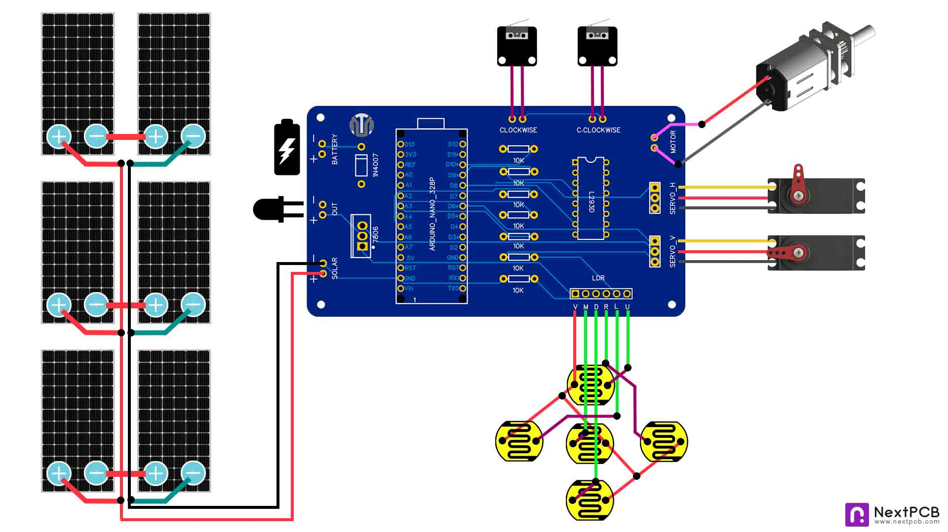



### ARDUINO CODE EXPLANATION

* + 1. **CODE:**

#include <Servo.h>

Servo horizontal, vertical;

const int servohLimitHigh = 175, servohLimitLow = 5;

const int servovLimitHigh = 130, servovLimitLow = 0;

int servoh = 90, servov = 30; // Start positions

const int ldrld = A1, ldrrd = A3, ldrlt = A2, ldrrt = A4, ldrmt = A5;

const int motorA = 7, motorB = 8;

bool motorState = false;

void setup()

{

    horizontal.attach(5);

    vertical.attach(6);

    horizontal.write(servoh);

    vertical.write(servov);

    pinMode(motorA, OUTPUT);

    pinMode(motorB, OUTPUT);

    closeMotor();

}

void loop()

{

    if (analogRead(ldrmt) > 300)

    {

        if (!motorState) openMotor();

       adjustServos();

    }

    else if(analogRead(ldrmt) < 200)

    {

        if (motorState) closeMotor();

        resetServos();

    }

}

void adjustServos()

{

    int lt = analogRead(ldrlt), rt = analogRead(ldrrt);

    int ld = analogRead(ldrld), rd = analogRead(ldrrd);

    int avt = (lt + rt) / 2, avd = (ld + rd) / 2;

    int avl = (lt + ld) / 2, avr = (rt + rd) / 2;

    int dvert = avt - avd, dhoriz = avl - avr;

    const int tol = 90;

if (abs(dvert) > tol) servov = constrain(servov + (dvert > 0 ? 1 : -1), servovLimitLow, servovLimitHigh);

 if (abs(dhoriz) > tol) servoh = constrain(servoh + (dhoriz > 0 ? -1 : 1), servohLimitLow, servohLimitHigh);

    vertical.write(servov);

    horizontal.write(servoh);

    delay(100);

}

void resetServos()

{

    horizontal.write(90);

    vertical.write(30);

    delay(100);

}

void openMotor()

{

  digitalWrite(motorA, HIGH);

    digitalWrite(motorB, LOW);

    delay(2500);

    digitalWrite(motorA, LOW);

    digitalWrite(motorB, LOW);

    motorState = true;

}

void closeMotor()

{

    digitalWrite(motorA, LOW);

    digitalWrite(motorB, HIGH);

    delay(2500);

    digitalWrite(motorA, LOW);

    digitalWrite(motorB, LOW);

    motorState = false;

}

* + 1. **EXPLANATION:**

1. **Library Inclusion and Variable Declaration**

The code starts by including the Servo.h library, which allows control of servo motors. Two servo objects are declared: horizontal and vertical. Initial positions for each servo and their movement limits are defined to prevent over-rotation. LDR pins and motor control pins are also declared, along with a boolean variable motorState to track whether the motor is open or closed.

1. **setup() Function**

This function initializes the servos by attaching them to digital pins 5 and 6. The starting positions are set using write() commands. The motor control pins (7 and 8) are configured as output, and the motor is initially set to a closed state using the closeMotor() function.

1. **loop() Function**

This function continuously checks the light intensity from the middle-top LDR (ldrmt). If the light intensity is greater than 300, it opens the protective motor cover if not already open and calls the adjustServos() function to track the sun. If the intensity falls below 200, the motor is closed and the servos are reset to default positions.

1. **adjustServos() Function**

This is the core tracking logic. It reads analog values from the four directional LDRs (top-left, top-right, bottom-left, bottom-right). Average light values are calculated to determine both horizontal and vertical differences. If the difference exceeds a defined tolerance (90), the servos are adjusted to turn the panel towards the brighter side. constrain() ensures that servo angles remain within their limits.

1. **resetServos() Function**

This function resets the solar panel to its original position (horizontal: 90, vertical: 30) and adds a short delay. It is typically called during sunset or in low-light conditions.

1. **openMotor() and closeMotor() Functions**

These functions control the motor connected to the panel cover. openMotor() sets the motor to open the cover, and closeMotor() closes it. Both functions run the motor for 2.5 seconds using delay() and then turn off both motor pins. The motorState boolean is updated accordingly.

* 1. **FLOW DIAGRAM**
     1. **DIAGRAM:**

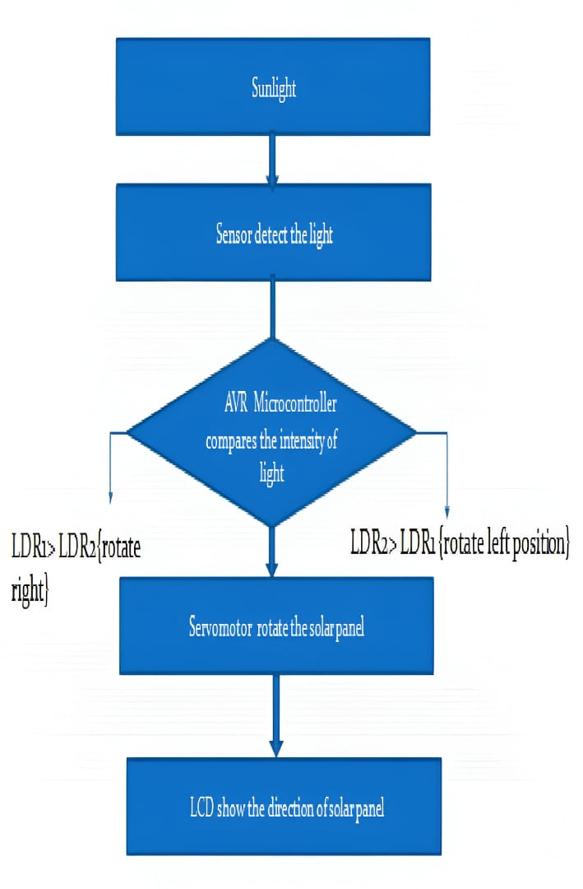

* + 1. **EXPLAINATION:**
       1. **Sunlight:**  
          The process begins with the natural availability of sunlight, which is the primary energy source for the Sunflower Solar Tracking System. Sunlight falls on the solar panel setup, triggering the system to begin monitoring and optimizing panel orientation for maximum energy absorption.
       2. **Sensor detects the light:**

Light Dependent Resistors (LDRs) are employed as light sensors to detect the intensity of sunlight from different directions. These sensors play a crucial role in identifying which direction receives more light, enabling the system to determine the sun’s current position in the sky.

* + - 1. **AVR Microcontroller compares the intensity of light:**

The sensor readings are sent to the AVR microcontroller, which acts as the brain of the system. It compares the light intensity detected by different LDRs. The comparison helps to identify which side (left or right) is brighter, guiding the movement of the solar panel accordingly.

* + - 1. **Condition – LDR1 > LDR2 {right} / LDR2 > LDR1 {left}:**

Based on the comparison, the system takes a decision. If LDR1 detects more light than LDR2, the microcontroller sends a signal to rotate the solar panel to the right. Conversely, if LDR2 receives more light than LDR1, it commands a rotation to the left. This ensures continuous alignment with the sun.

* + - 1. **Servomotor rotates the solar panel:**

Upon receiving the microcontroller's instructions, the servo motor adjusts the position of the solar panel. This mechanical movement aligns the panel in the optimal direction, increasing its exposure to sunlight and thereby enhancing energy collection.

* + - 1. **LCD shows the direction of the solar panel:**

As the final step, an LCD display is used to indicate the current direction in which the solar panel is facing. This helps in monitoring and provides visual feedback to users, confirming the operational status and orientation of the system.

* 1. **CONCEPTUAL DIAGRAM**
     1. 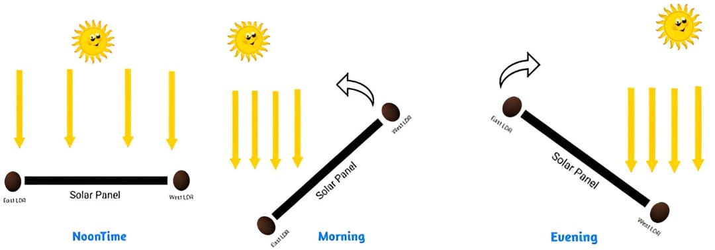**DIAGRAM:**
     2. **EXPLANATION:**
        1. **Morning:**

In the morning, the sun rises from the east, and sunlight hits the east-facing LDR (Light Dependent Resistor) more directly. As a result, the east LDR detects higher light intensity compared to the west LDR. The microcontroller compares the light levels from both LDRs and sends a signal to the servo motor to rotate the solar panel towards the east. This rotation aligns the panel perpendicularly to the sunlight, maximizing energy absorption during the early hours.

* + - 1. **Noon Time:**

During noon, the sun is positioned directly above, and sunlight falls equally on both the east and west LDRs. Since both LDRs receive nearly the same intensity of light, the microcontroller does not trigger any movement. The solar panel remains in a horizontal position, as it is already optimally aligned with the sun’s position. This state represents the most balanced light condition where no correction is needed.

* + - 1. **Evening:**  
         In the evening, as the sun begins to set in the west, the west-facing LDR receives more sunlight than the east LDR. The system detects that the west LDR has a higher intensity, prompting the microcontroller to instruct the servo motor to rotate the panel towards the west. This ensures the solar panel remains aligned with the setting sun, allowing for continued energy collection until sunset.
      2. **Solution:**

This project, Sunflower Solar Tracking System keeps the solar panels perpendicular to the sunlight, hence increasing the output by 2.5 – 3 times.

* 1. **DATA FLOW DIAGRAMS**

DFD is the abbreviation for Data Flow Diagram. The flow of data of a system or a process is represented by DFD. It also gives insight into the inputs and outputs of each entity and the process itself. DFD does not have control flow and no loops or decision rules are present. Specific operations depending on the type of data can be explained by a flowchart. It is a graphical tool, useful for communicating with users, managers and other personnel. it is useful for analyzing existing as well as proposed system. It shows how data enters and leaves the system, what changes the information, and where data is stored.

The objective of a DFD is to show the scope and boundaries of a system as a whole. It may be used as a communication tool between a system analyst and any person who plays a part in the order that acts as a starting point for redesigning a system. The DFD is also called as a data flow graph or bubble chart.

# 



# Data Flow Diagram Level 0

# Data Flow Diagram Level 1

# Data Flow Diagram Level 2

# STATE CHART DIAGRAM

# CHAPTER 6

# APPLICATIONS

# CHAPTER 6

# APPLICATIONS

* 1. **RESIDENTIAL SOLAR POWER SYSTEMS**

In residential areas, energy consumption continues to rise with the increasing use of electronic appliances. Traditional solar panels, although effective, often suffer from reduced efficiency due to their fixed position. By using a dual-axis Sunflower Solar Tracking System, homeowners can significantly improve energy capture by ensuring the panels always face the sun directly. This dynamic alignment leads to up to 40% more power generation compared to fixed panels. Additionally, it allows homes in both urban and rural settings to become more energy independent, reducing electricity bills and promoting a greener lifestyle.

* 1. **AGRICULTURAL IRRIGATION SYSTEMS**

Farmers, especially in remote and off-grid locations, often face challenges with reliable power sources for irrigation. Integrating the Sunflower Solar Tracker into solar-powered irrigation systems ensures maximum sunlight capture throughout the day, even during changing weather patterns. This guarantees that water pumps receive consistent power for effective irrigation. It helps in improving crop yield, reducing reliance on diesel pumps or unstable power grids, and minimizing environmental impact. Moreover, since the system requires minimal maintenance, it is highly suitable for large farmlands.

* 1. **STREET LIGHTING AND PUBLIC UTILITIES**

Public lighting infrastructure, such as streetlights, highway signs, and traffic lights, can benefit immensely from the solar tracking system. These applications require steady power, especially during evening hours. With improved solar capture during the day using the Sunflower Solar Tracker, batteries can be fully charged and sustain operations overnight. It reduces the need for wired electrical connections, which can be expensive and difficult to install in remote or rural areas. Additionally, it contributes to lower public energy consumption and supports smart city initiatives.

* 1. **COMMERCIAL AND INDUSTRIAL USE**

Industries and commercial facilities consume vast amounts of electricity daily. Incorporating solar panels equipped with sun tracking mechanisms can significantly reduce electricity expenses by increasing solar energy yield. Whether for running machinery, lighting, or HVAC systems, the improved efficiency helps offset the carbon footprint and reliance on traditional energy sources. In addition, industries can meet government-mandated renewable energy targets more easily while saving costs in the long run. Businesses can also market their green energy practices, enhancing their brand image and environmental responsibility.

* 1. **REMOTE RESEARCH OR MILITARY CAMPS**

Military outposts, forest research stations, and disaster-relief camps are often located in regions with limited or no access to a power grid. The Sunflower Solar Tracking System offers a robust, self-sufficient energy solution for such areas. It can power communication equipment, lighting, computers, and other essential systems without external power sources. The system's portability, low maintenance, and energy efficiency make it ideal for these critical applications, where reliable energy access is a matter of operational continuity and safety.

# CHAPTER 7

# RESULTS

#### CHAPTER 7

**RESULTS**

The solar panel sun tracking system was successfully developed and implemented using a microcontroller, servo motor, and LDR sensors. The system accurately detected the sun's position by comparing light intensities between the east and west LDRs. Based on the light input, the microcontroller controlled the servo motor to adjust the solar panel’s angle, ensuring it remained perpendicular to the sunlight throughout the day. This dynamic adjustment significantly increased the efficiency of solar energy capture compared to fixed-position panels. The successful demonstration of this working model proves its potential for real-world applications in improving renewable energy systems.

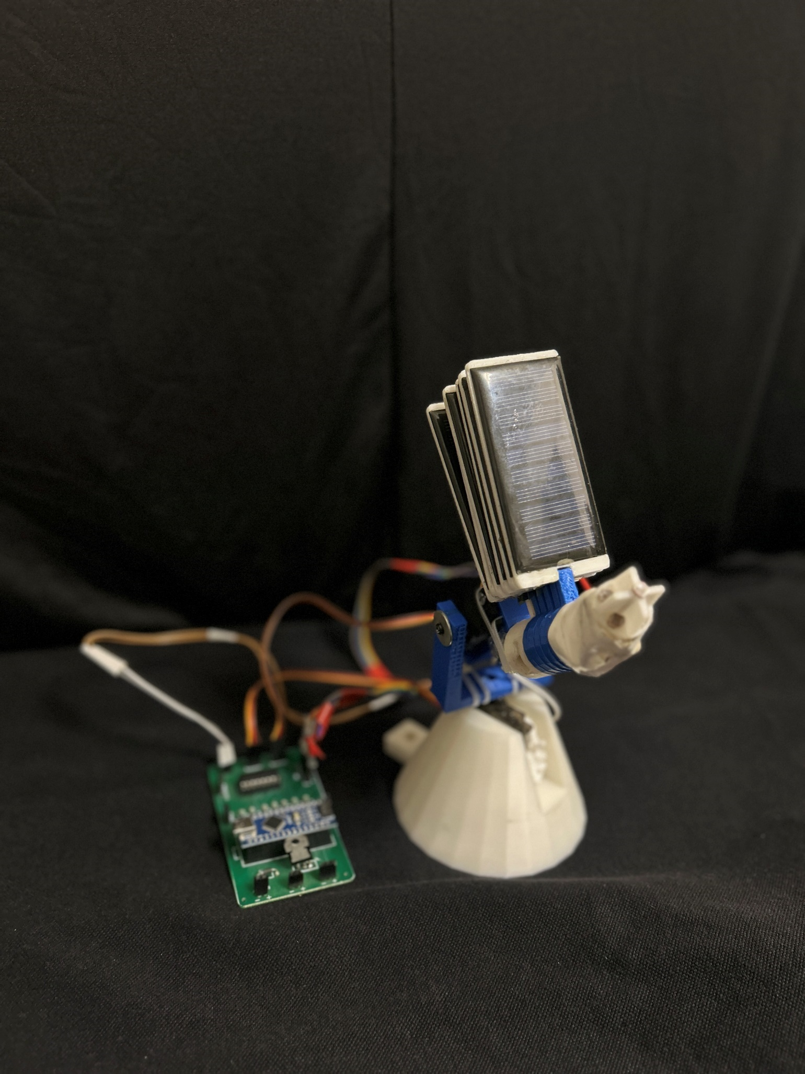

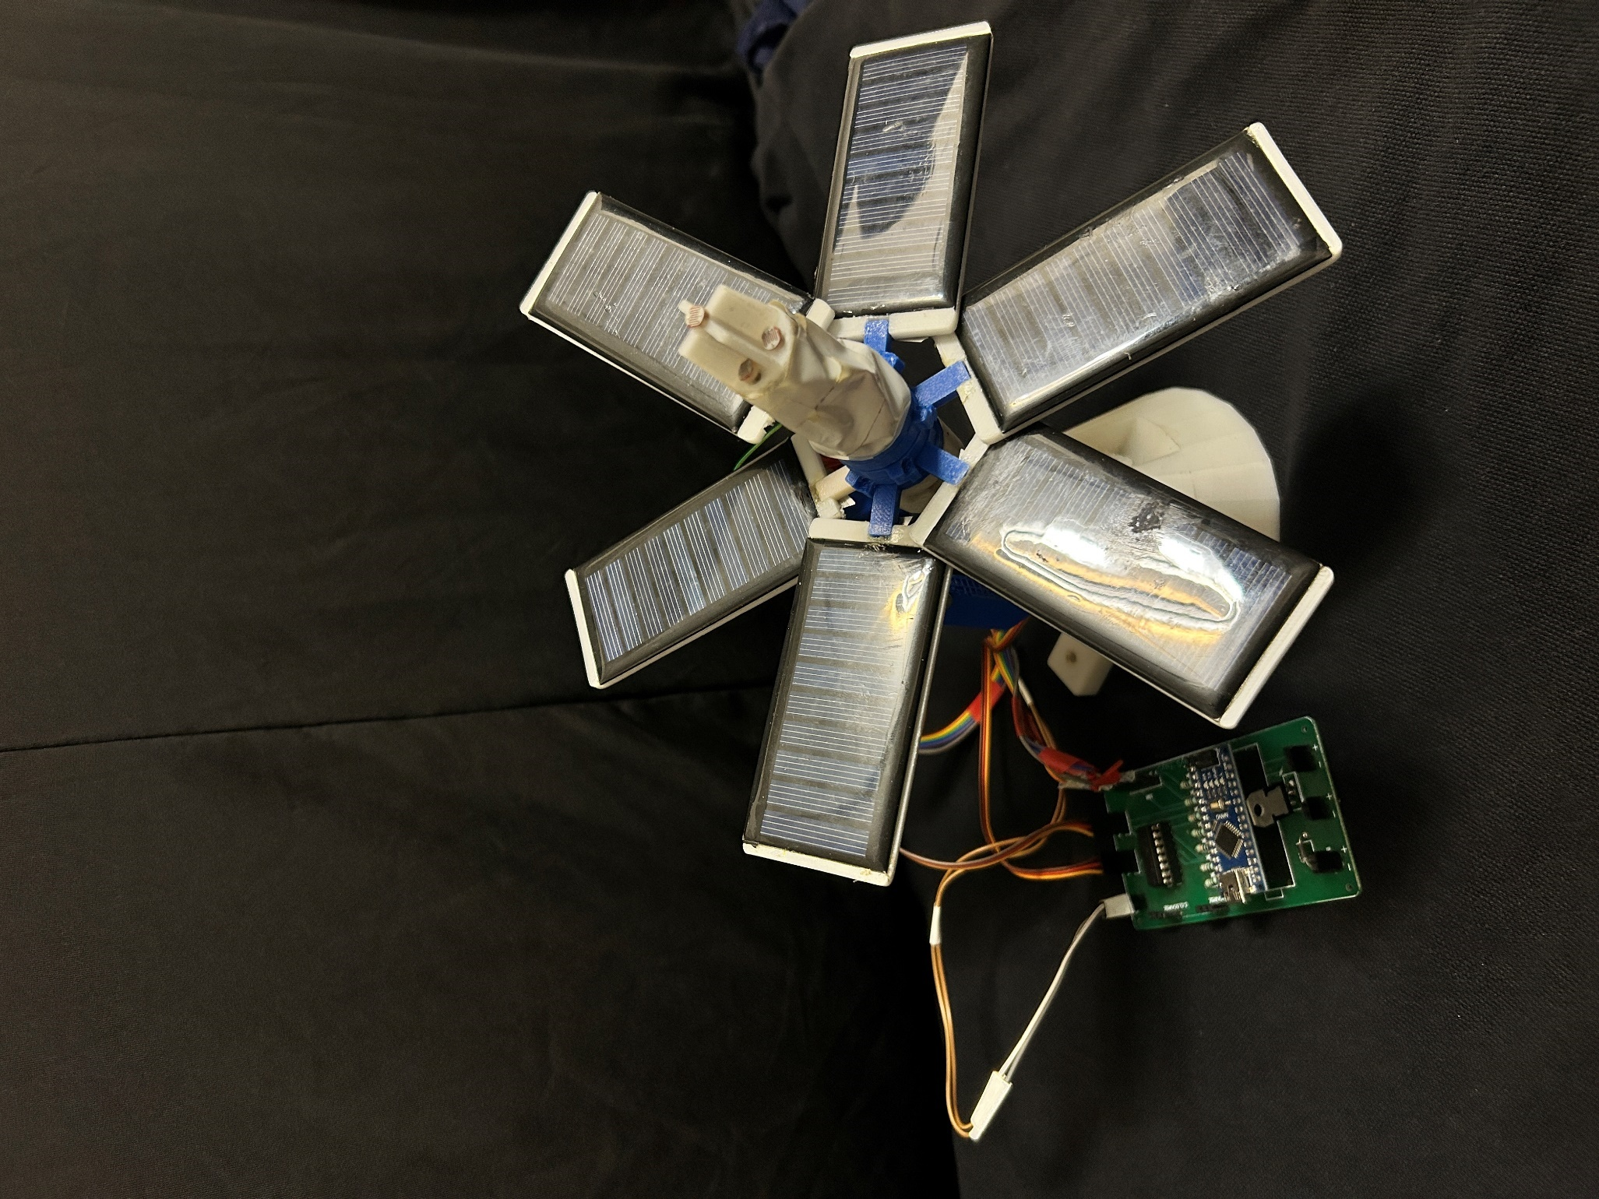

# CHAPTER 8

# TESTING

#### CHAPTER 8

**TESTING**

**8.1 SYSTEM TESTING**

System testing is a critical phase in any hardware-software integrated project, where the complete system is tested as a whole to ensure that it performs the intended function under various conditions. In the Solar Panel Sun Tracking System, system testing was carried out after the successful assembly of all components including the solar panel, light-dependent resistors (LDRs), microcontroller (such as Arduino Nano), servo motor, and power supply unit. The objective of this phase was to evaluate the system’s response to actual sunlight and to ensure the automatic rotation mechanism functions properly.

The test setup was exposed to natural sunlight at different times of the day: morning, noon, and evening. During the testing, both LDRs continuously sensed the sunlight intensity. Based on their readings, the microcontroller decided whether the solar panel should move to the left or right to face the sun. The servo motor then adjusted the position of the panel accordingly. The system consistently responded as per the logic coded in the microcontroller, confirming that the integration of sensors and actuators was successful. This validated the reliability of the entire tracking mechanism under real-world conditions.

**8.2 TESTING TECHNIQUES**

Various software and hardware-based testing techniques were used to validate the performance of the solar tracking system. Primarily, the black box testing approach was followed, where the internal logic was not altered during testing, but the system's response to various light conditions was monitored.

The key technique involved directional light simulation, wherein the light source (in real conditions or by using a torch in lab testing) was moved gradually from east to west to mimic the sun's movement. Observations were made on how the LDRs responded and how promptly and accurately the servo motor rotated the panel. Additionally, load testing was performed to check the endurance of the system when exposed to continuous sunlight for extended durations. Manual overrides were also introduced in some tests to ensure that the panel could recover and recalibrate automatically. Each test case was repeated multiple times to confirm the repeatability of the results.

**8.3 ACCURACY EVALUATION**

Accuracy evaluation is essential in determining the effectiveness of the solar tracking mechanism. In this project, accuracy was assessed based on how closely the panel aligned itself to the direct path of the sunlight. During different times of the day, the angular difference between the actual position of the sun and the orientation of the solar panel was measured. It was found that the panel was able to align within ±10 degrees of the sun’s path, which is acceptable for a prototype system.

The evaluation also considered the response time of the system—the delay between change in light intensity and panel movement. This delay was minimal, ranging between 1–2 seconds, depending on ambient light fluctuations. Furthermore, energy efficiency was calculated by comparing the energy output of the tracking system with that of a stationary solar panel. Results indicated that the tracking system generated up to 20–25% more energy throughout the day. This confirms that the tracking algorithm and hardware implementation successfully increased solar exposure, thereby improving overall system efficiency.

# CHAPTER 9

# FUTURE SCOPE

**CHAPTER 9**

**FUTURE SCOPE**

The Solar Panel Sun Tracking System has the potential to bring a significant revolution in the field of renewable energy. As the world shifts toward sustainable and green energy sources, innovations like this tracking system play a crucial role in maximizing energy efficiency, reducing dependency on fossil fuels, and addressing the growing energy demands of various sectors. Below are the key future developments envisioned for this project:

1. **REVOLUTIONIZING RENEWABLE ENERGY ADOPTION**

This system will serve as a major breakthrough in solar energy harvesting by enabling intelligent tracking solutions at an affordable cost. By increasing energy output by up to 25–30%, it makes solar panels more viable and productive, pushing the boundaries of what’s currently achievable with static panels. Widespread implementation could drastically reduce electricity costs and carbon footprints worldwide.

1. **MULTIPLE VERSIONS DEPENDING UPON REQUIREMENT**

**VERSION 1: DOMESTIC USE:**

A compact and affordable version of the system will be developed for residential rooftops. It will help homeowners gain more power from their existing solar panels, contributing to self-sufficient and green households. This version will be lightweight, easy to install, and maintenance-friendly.

**VERSION 2: SMALL-SCALE INDUSTRY USE:**

A medium-capacity system will be tailored for small-scale industries, farms, and remote offices, ensuring higher energy yields for operations in rural or semi-urban regions. It will include added durability, weatherproof design, and wireless monitoring via mobile apps or local dashboards.

**VERSION 3: LARGE-SCALE INDUSTRY USE:**

For industrial-scale solar farms and large commercial setups, an advanced, high-capacity version will be launched. This model will support dual-axis tracking, cloud-based analytics, and smart grid integration for real-time power distribution and efficiency analysis. AI-based optimization can also be incorporated to predict sun paths based on geographic data and weather forecasting.

1. **INTEGRATION WITH IOT AND SMART MONITORING:**

Future versions will include IoT-enabled modules for remote monitoring and control. Data such as panel position, energy output, sunlight intensity, and maintenance alerts can be accessed through smartphones or web applications, making solar energy smarter and more user-friendly.

1. **CONTRIBUTION TO SMART CITIES AND GREEN ARCHITECTURE:**

As smart cities become a reality, these intelligent sun tracking systems can be integrated into smart buildings, eco-communities, and urban infrastructures to reduce power loads and promote sustainability.

* **AUTOMATED SOLAR CHARGING STATIONS**

In the near future, we envision building **Automated Solar Charging Stations** specifically designed for **electric vehicles (EVs)**, powered entirely by our **Sunflower Solar Tracking System**. These stations will operate **independently of the conventional power grid**, producing and storing their own solar energy for continuous, off-grid operation.

This innovation is not just an upgrade—**it’s a game-changer**. These charging stations will be capable of functioning in **remote and rural areas** where electricity infrastructure is either weak or non-existent. Using solar tracking technology, the system will **maximize energy absorption** by adjusting the orientation of solar panels throughout the day, just like a sunflower follows the sun. The energy collected will be stored in high-capacity batteries and used to charge EVs or power local equipment.

What makes this idea revolutionary is its **self-sufficiency**. There will be no dependency on external power sources or fuel. The station will generate, manage, and utilize its own energy—**a closed-loop system** requiring minimal human intervention. This will pave the way for **sustainable mobility** even in the most disconnected regions of the world.

These stations could soon become the **backbone of green transportation**, bringing renewable energy to places never thought possible and eliminating the need for traditional charging infrastructure. By combining mobility with sustainability, **this project aims to fuel the future with the power of the sun—anytime, anywhere.**

* **SUMMARY**

In summary, the **Solar Panel Sun Tracking System** is more than just a project, it marks the beginning of a shift toward smarter and more efficient solar energy use. Inspired by the sunflower’s natural ability to follow the sun, this system solves a key limitation of conventional fixed solar panels by continuously adjusting the panel orientation to maximize sunlight capture throughout the day.

This improved efficiency helps generate more power, increases the return on investment, and encourages the broader adoption of renewable energy. The project is designed with versatility in mind, offering three scalable versions tailored for domestic use, small-scale industries, and large-scale applications. This adaptability ensures it can contribute meaningfully to energy needs across various sectors.

By combining automation, microcontroller control, light sensors, and servo motor mechanisms, the system is energy-efficient, low-maintenance, and cost-effective. It works effectively under changing weather conditions and reduces dependence on non-renewable energy sources.

Looking forward, this innovation supports global sustainability efforts and has the potential to spark a **revolution in renewable energy practices**. With future enhancements, the system can play a vital role in building a **cleaner, greener, and more energy-resilient world**, proving that intelligent design and environmental responsibility can go hand in hand.

# CHAPTER 10

# CONCLUSION

**CHAPTER 10**

**CONCLUSION**

The Solar Panel Sun Tracking System project demonstrates an efficient method of maximizing solar energy capture by automatically orienting a solar panel toward the sun. Traditional fixed solar panels often suffer from reduced efficiency due to suboptimal alignment with the sun’s path. This project addresses that limitation by using a dynamic system that tracks the sun from sunrise to sunset, improving the total energy harvested throughout the day.

The system uses light-dependent resistors (LDRs) to detect sunlight intensity, a microcontroller (such as Arduino Nano or AVR) to process sensor inputs, and a servo motor to adjust the panel’s orientation. The system successfully rotated the panel in the correct direction and increased exposure to direct sunlight. The addition of an LCD display for real-time feedback added user interaction.

This project’s energy optimization capability showed a 20–25% improvement in efficiency compared to fixed panels, making it useful for off-grid or remote areas. It is scalable and can be enhanced with dual-axis tracking for greater precision.

In conclusion, the project enhances solar energy efficiency and serves as an application of embedded systems and sensor-based automation. It provides a foundation for future advancements, such as IoT monitoring, machine learning for adaptive tracking, and weather-based adjustments. The Solar Panel Sun Tracking System contributes to the global push for renewable energy technologies.

**“The full potential of the sun’s energy remains untapped; harnessing it to its maximum capacity is essential for a sustainable and renewable future.”**

# CHAPTER 11

**RESEARCH PAPER**

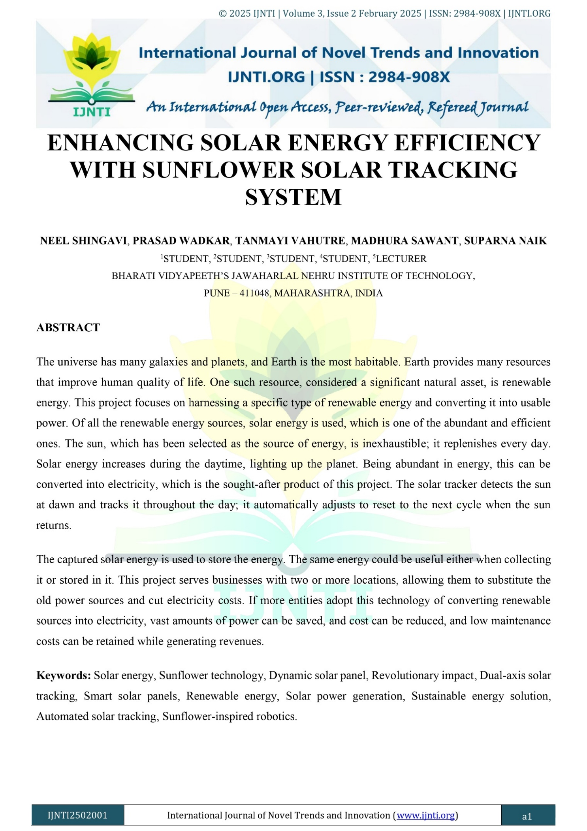

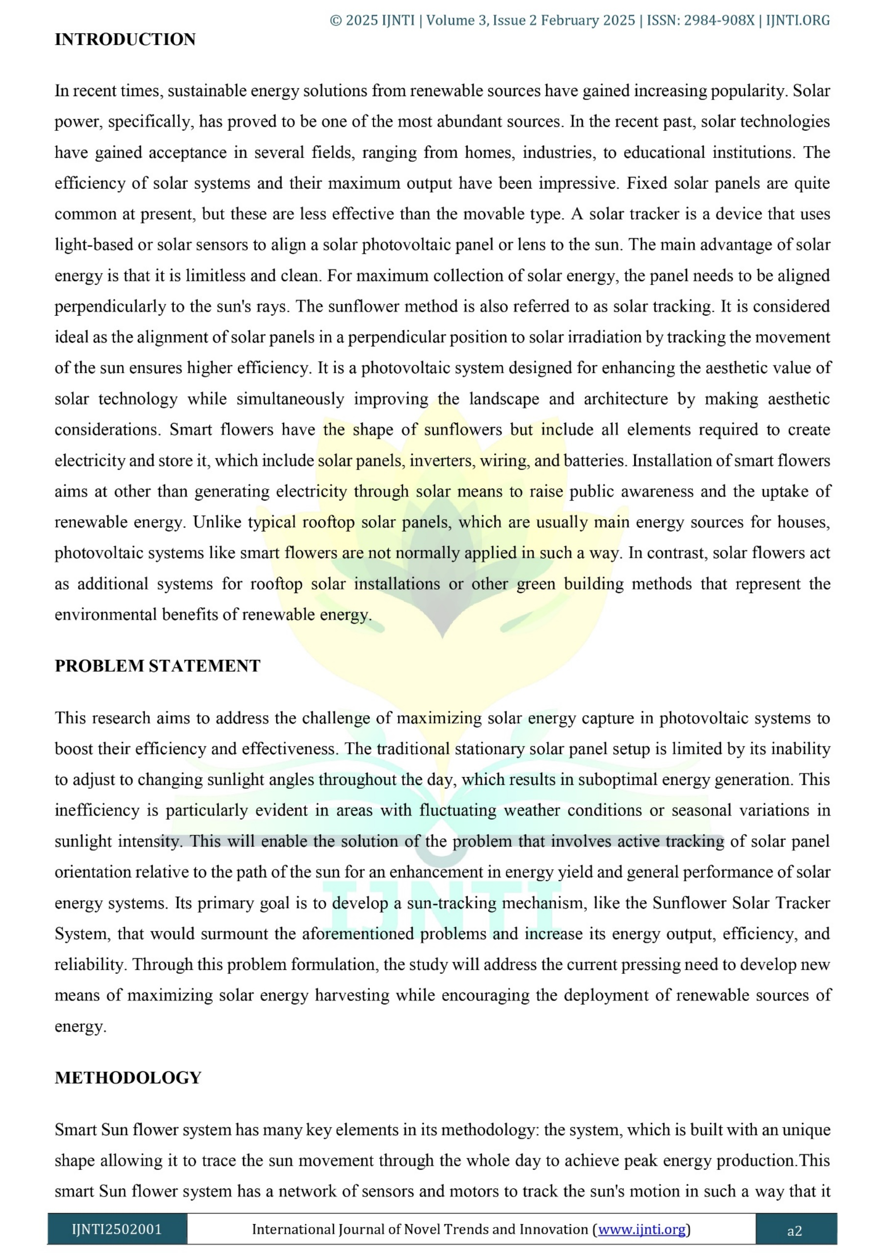

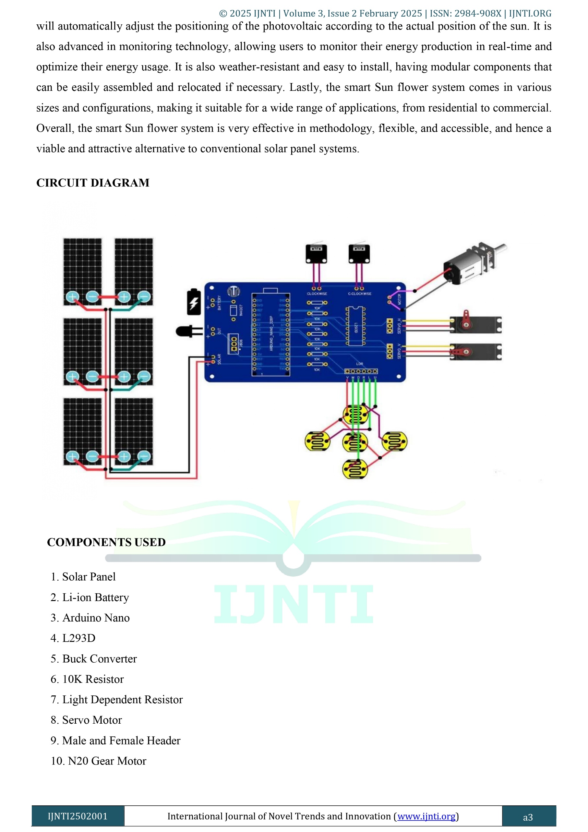

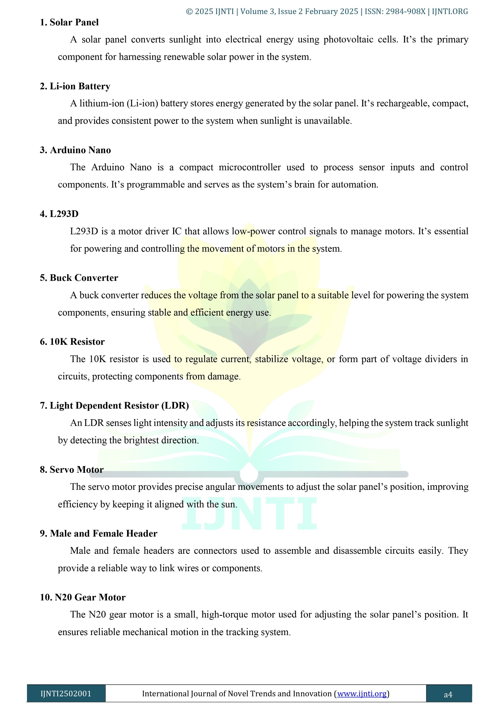

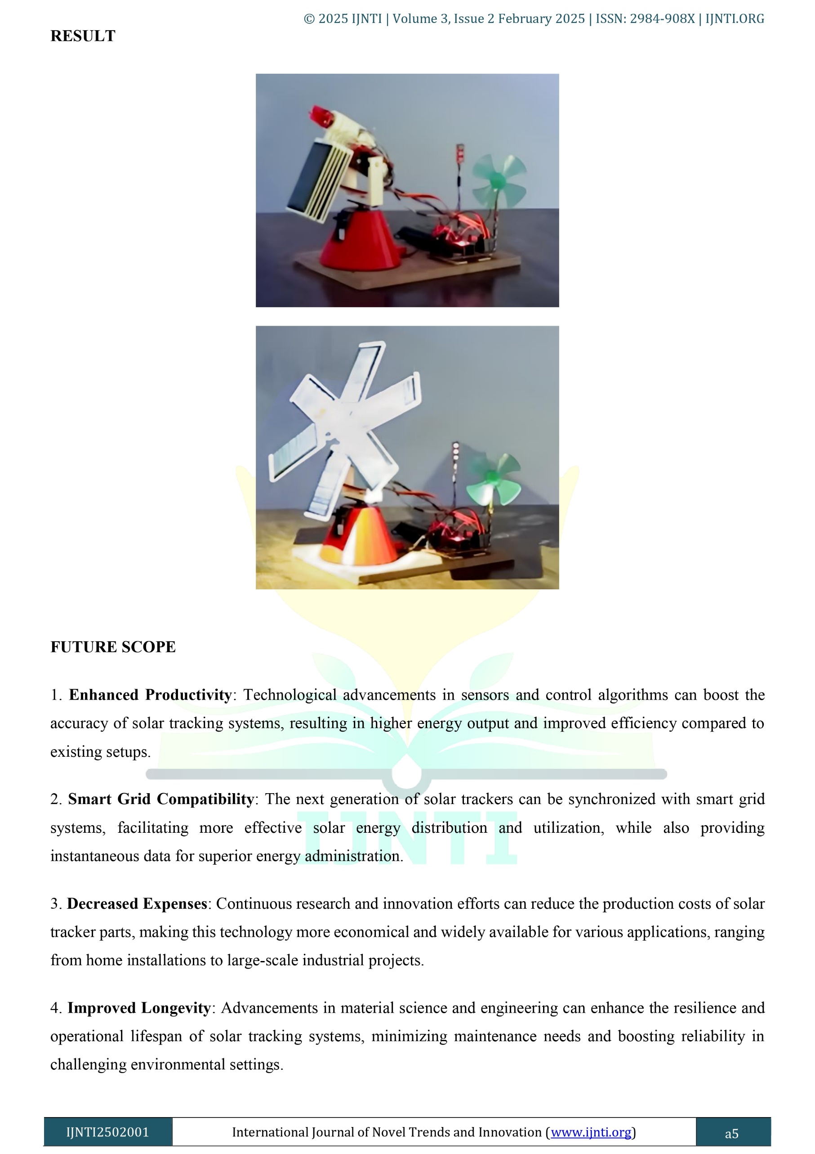

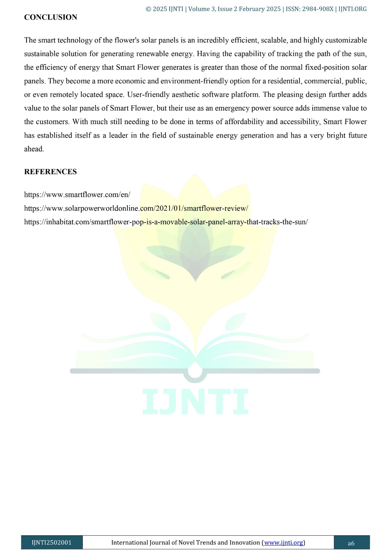

# CHAPTER 12

**CERTIFICATES**









